Milestone 2 Documentation
Name: Mohammed Junaid Betgeri
Mail: jemir0019@gmail.com
Project: Low-Code Dynamic Form Workflow & Data Collection Platform

Following is the Screenshot with their brief explanation:

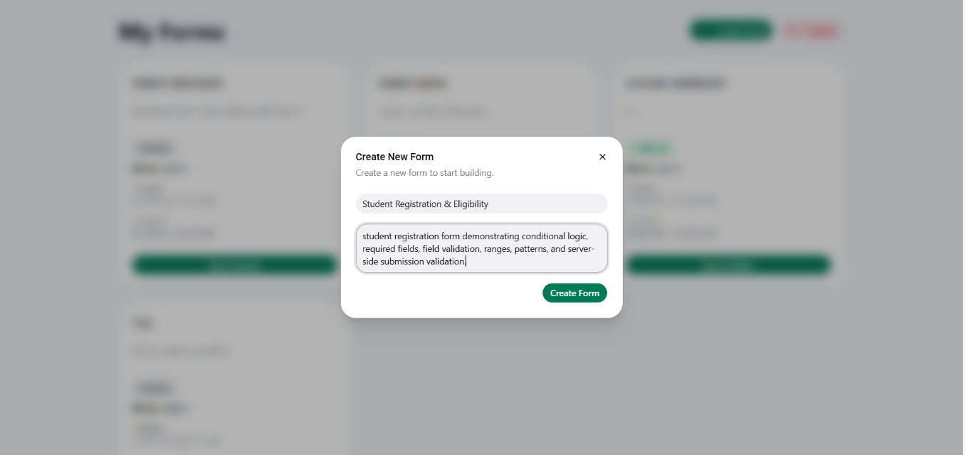
Creating a new form for milestone 2

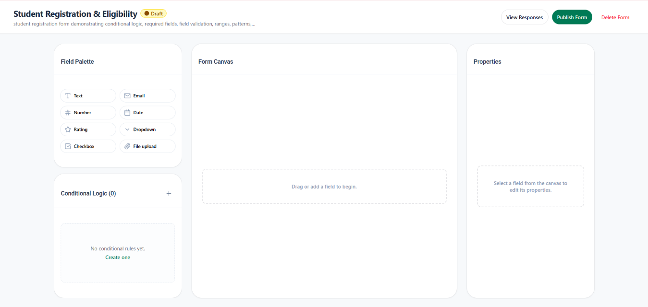
Improved the overall structure and UI of the form builder with more clarity and readability

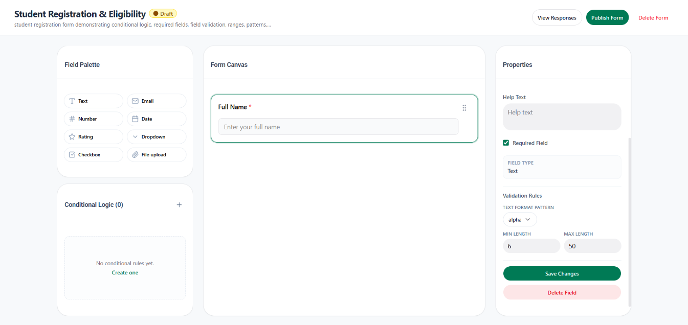
Added validation rules, Text format patter can be (any, alphanumeric only, string only). Also added the range (min and max length for the field)

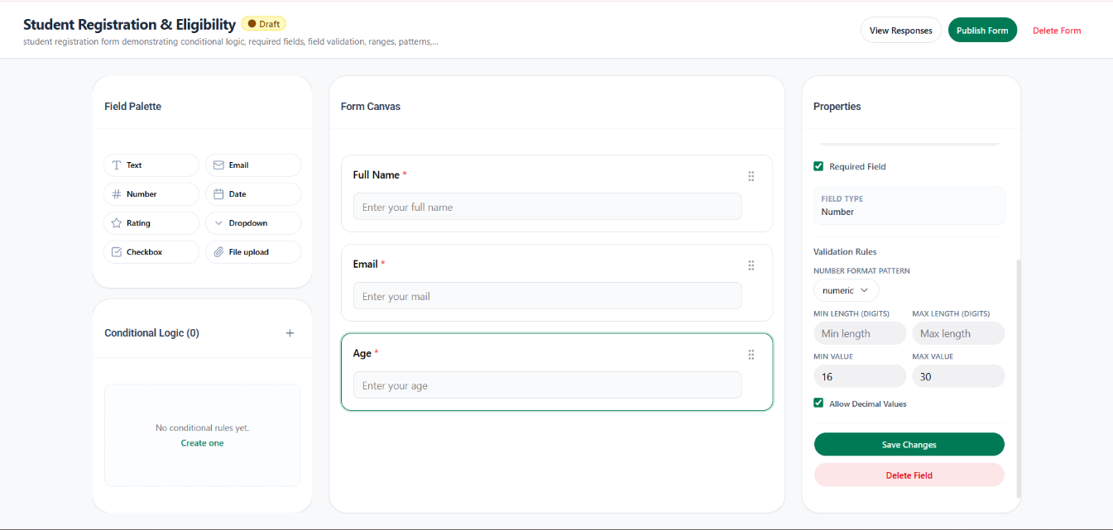
For number field added min value and max value acceptance rule, with number format pattern

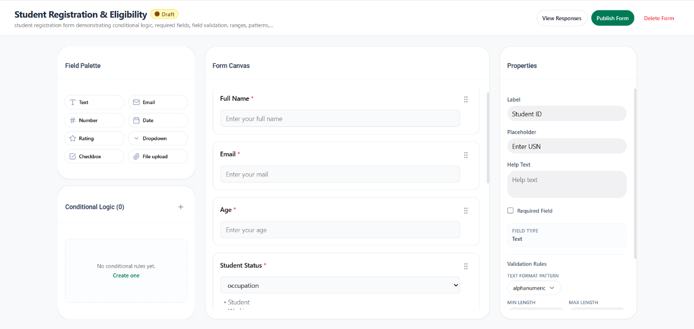

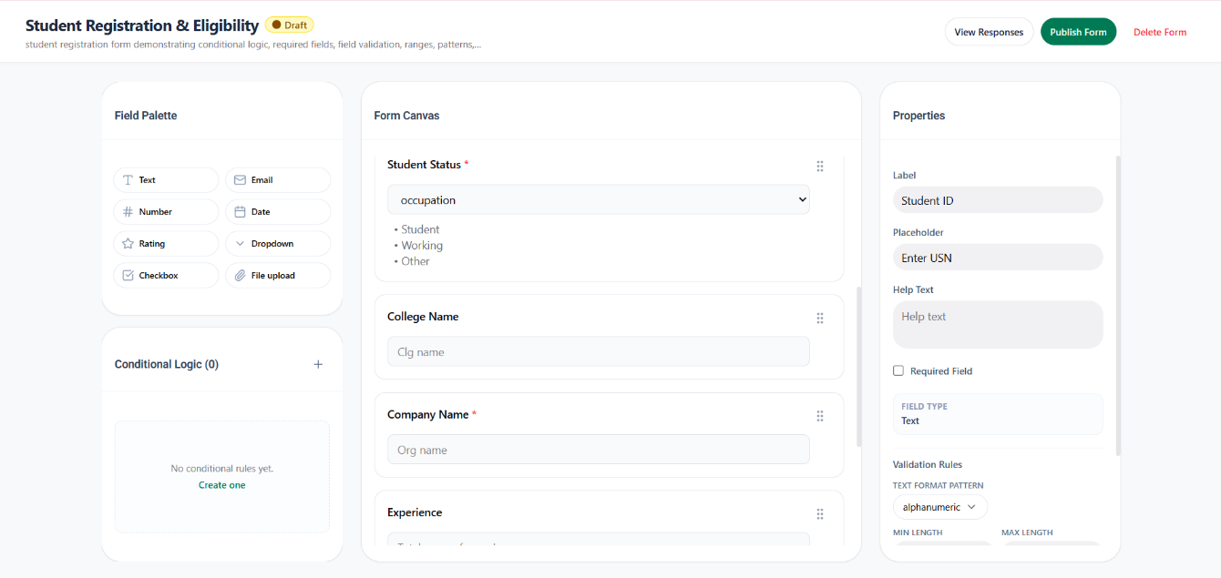

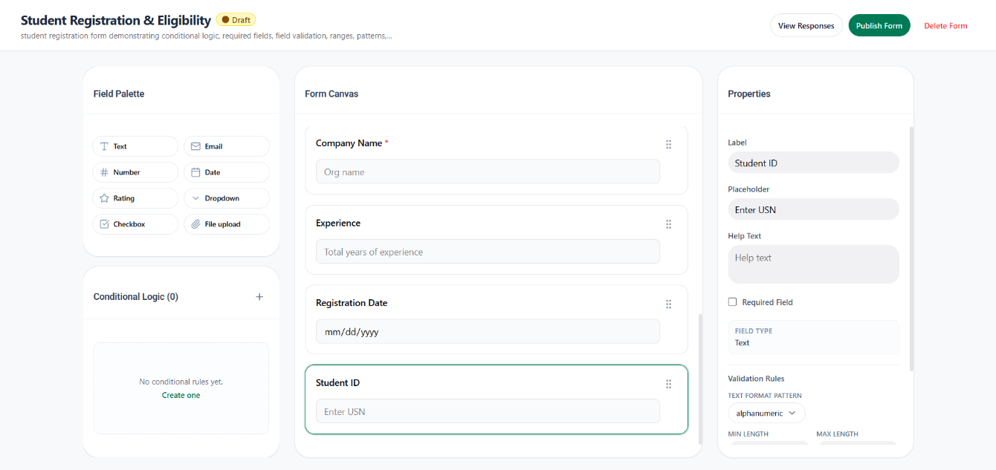
Created a complete form for milestone 2 as shown above in the screenshot

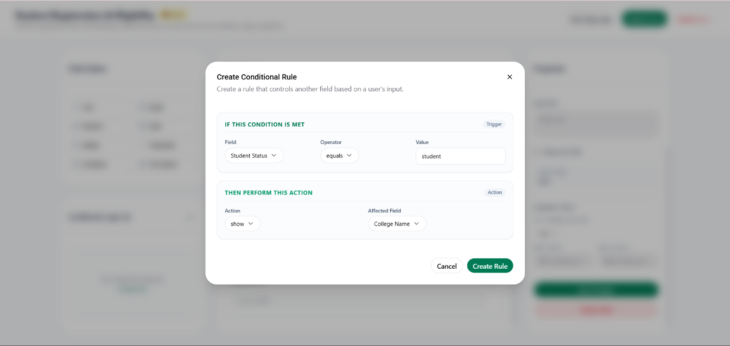
Conditional Rule for Student Status option when user selects the student option

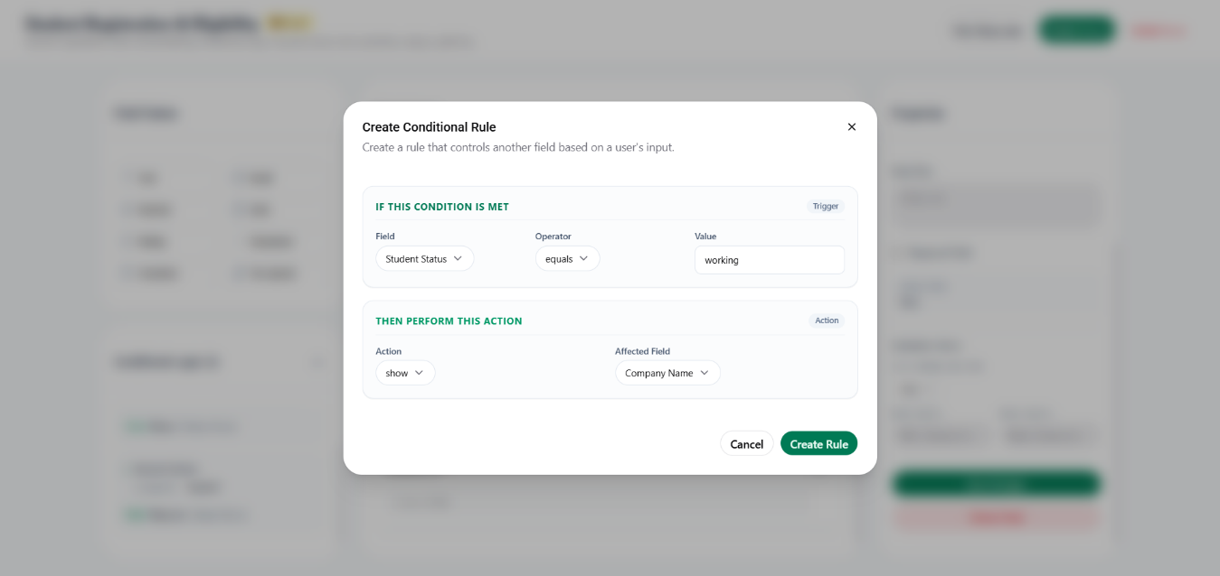
Conditional Rule for Student Status option when user selects the working option

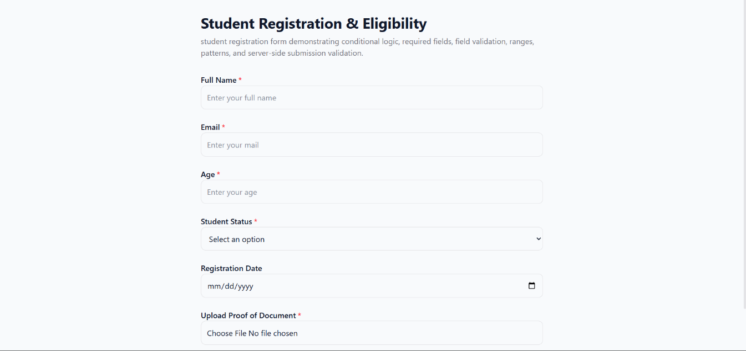
Public Form overview at first view

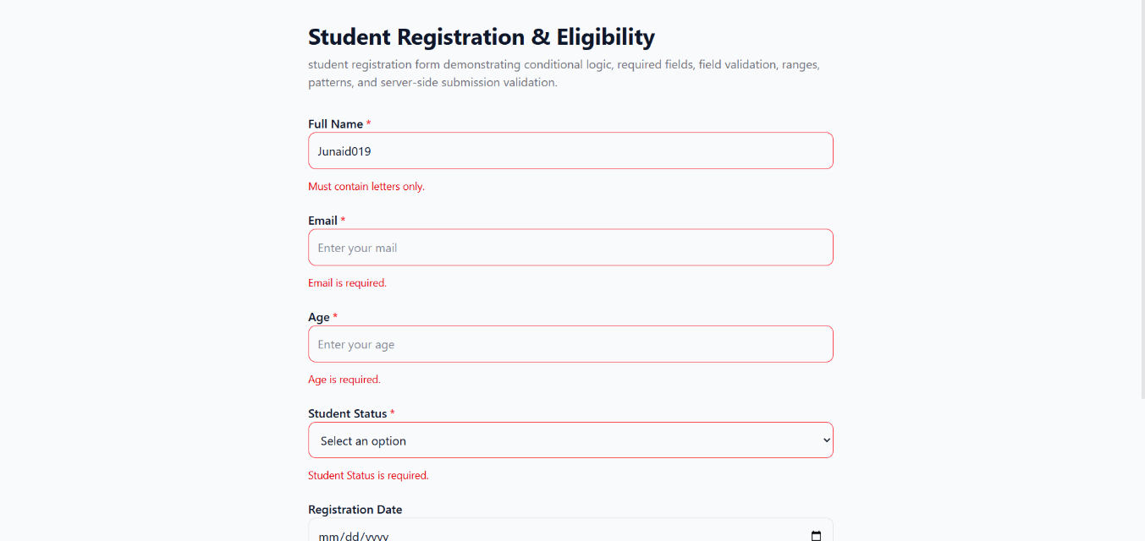
As you see text field name should only contain the character if numbers are entered the field throws an error with message

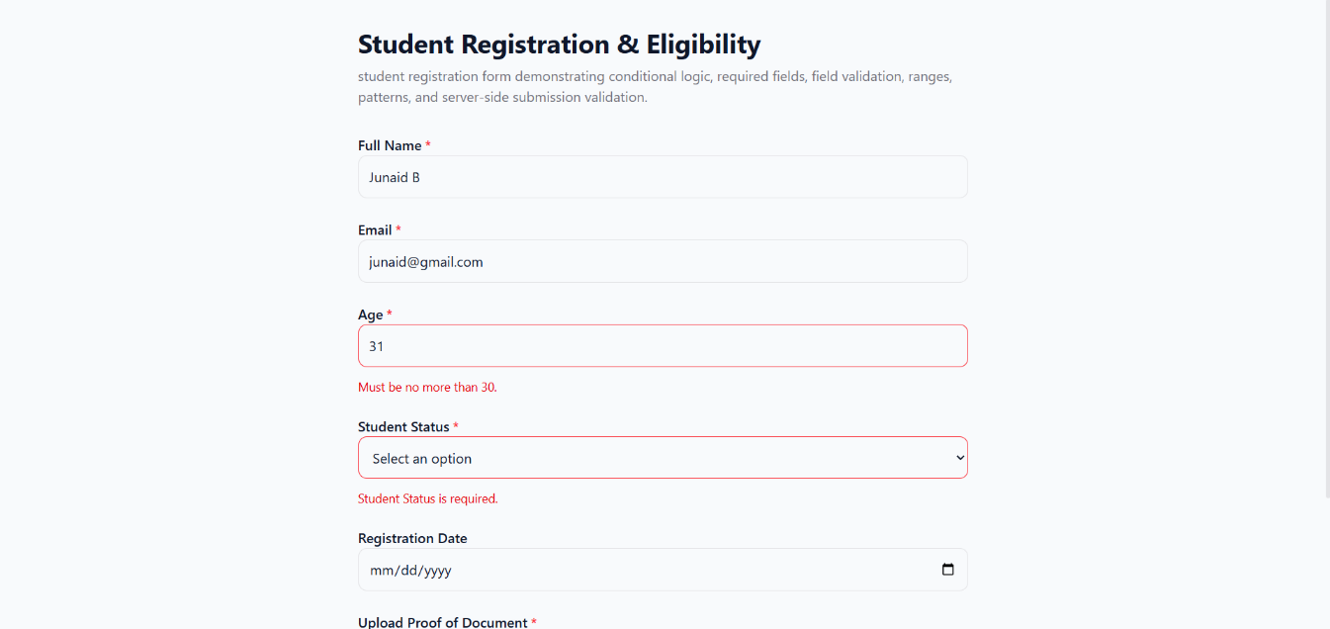
Age field throws an error when the number is greater than 30, as it only accepts the max value age till 30
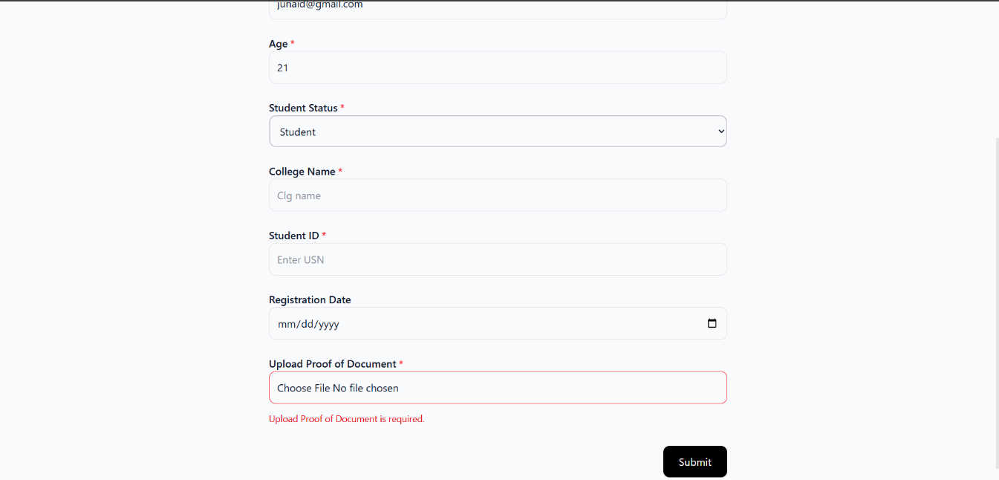
When Student Status option (student) is selected, the field associated with that option appears
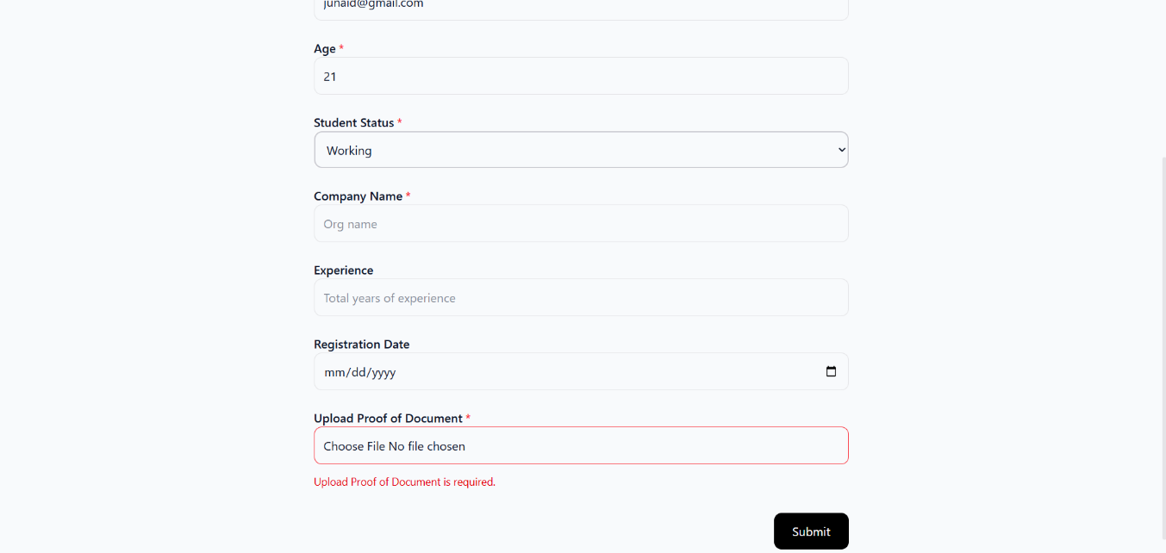
When Student Status option (working) is selected, the field associated with that option appears
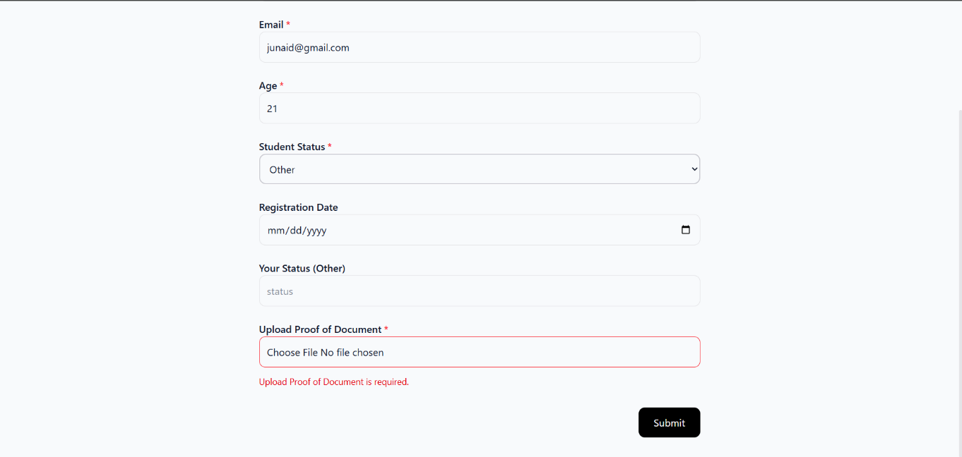
When Student Status option (other) is selected, the field associated with that option appears

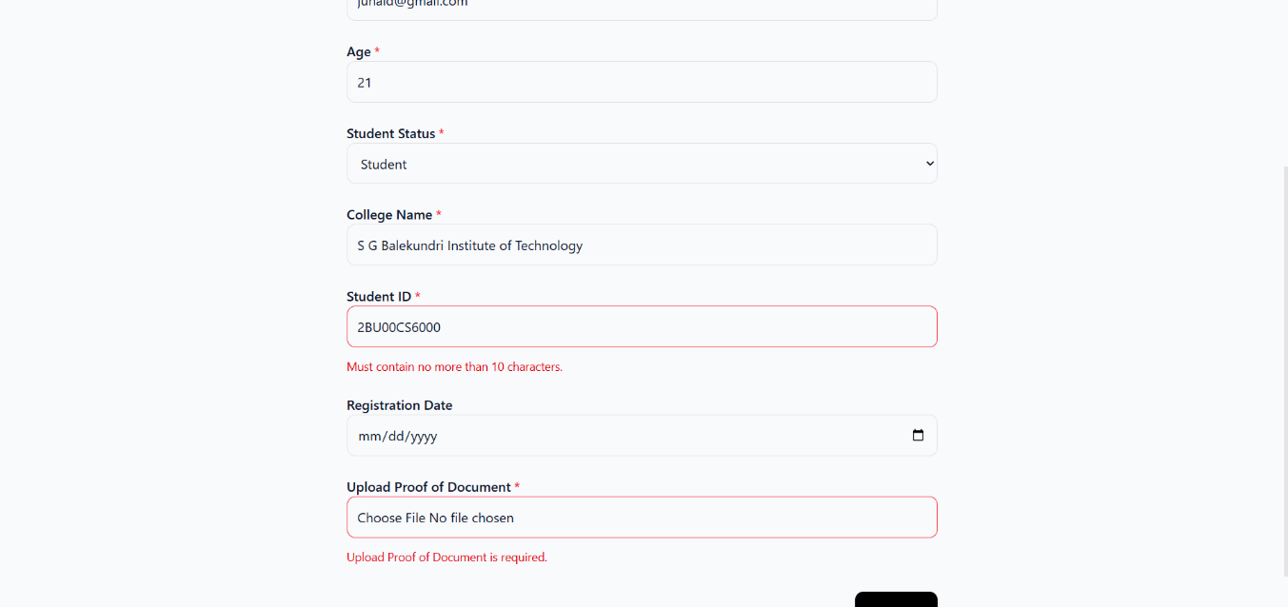
Student ID field has max length value of 10, so USN entered more than 10 Alphanumeric won’t be submitted

Once all details are filled with respective to their valid rules.
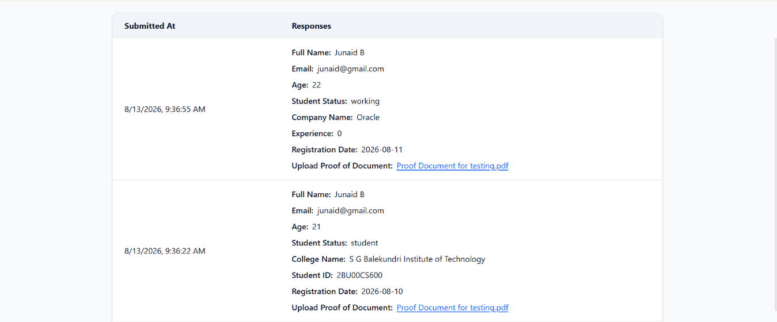
View Response page from the admin side, has two responses on for the option student and another for working.

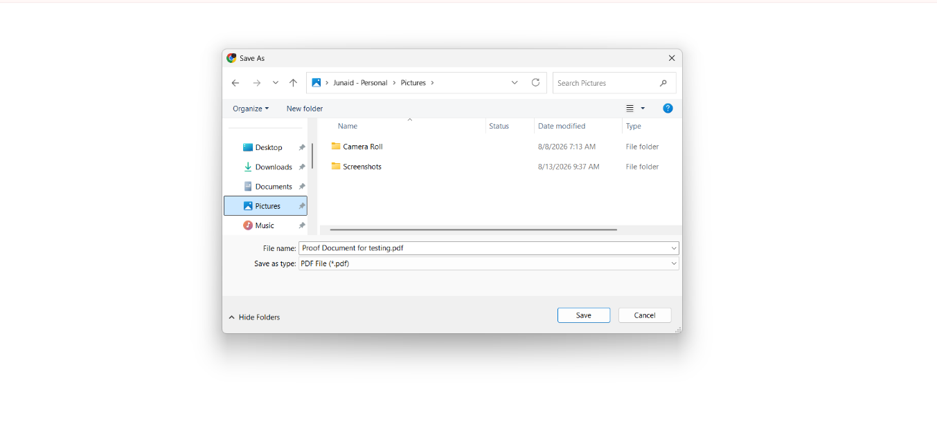
The admin is able to download the document submitted by the user by clicking the blue hyperlink with name of document in the view response page as seen in the previous screenshot.

